

**Black Isle Cares**

CHARITY NUMBER: SCO45371



Photo credit: Liam Skinner Photography

**February 2022**

Hello all and a happy 2022 to you all! Black Isle Cares has been back in action for a few weeks now, and we are as busy as ever planning for the next 12 months ahead. We are hoping this year we will be able to begin hosting face-to-face events again and kickstart our Intergenerational Games Afternoons at some point in the near future, as I know many of you enjoyed these sessions with the youngsters of Fortrose Academy in the past. Our current ventures are all going well and as always if you have any feedback then please let us know as we are always striving to enhance our projects!

**Volunteers collecting supplies**

Now that restrictions are beginning to lift, Black Isle Cares have made the decision that it is now safe for volunteers to visit the office to drop off money, collect supplies for delivery runs and various other volunteering roles. But please let our Project Coordinator, Megan, know if you plan to drop by in advance so she can have supplies and other goods ready for collection! Many thanks!

**Meals on Wheels update**

You may be aware that Chanterelle at the Rosemarkie and Fortrose Golf Club recently closed their doors and sadly we lost them as a Meals on Wheels supplier on a Monday and Friday last year. We will miss the fantastic meals that Lynsey and her team prepared for us, and we wish them all the success in their future ventures. We quickly made some changes to our Meals on Wheels project following the departure of Chanterelle and we were delighted when the team at Crofters in Rosemarkie agreed to step forward and pick up the Monday Meals on Wheels service on top of their existing Wednesday with us. We are also excited to announce that the Highland Farm Café in Dingwall are now our new Friday Meals on Wheels provider and so far, their meals have been great with many of you commenting on the quality and portion sizes. The meals wouldn’t be possible from the Highland Farm Café if it wasn’t for the support from Shop Mobility, who kindly offered to collect the meals on a Friday and deliver back over to Fortrose for our volunteers to distribute. We are very fortunate to feel the value of local businesses and other charities supporting our efforts in the community.

**St Andrews Day Celebrations 2021**

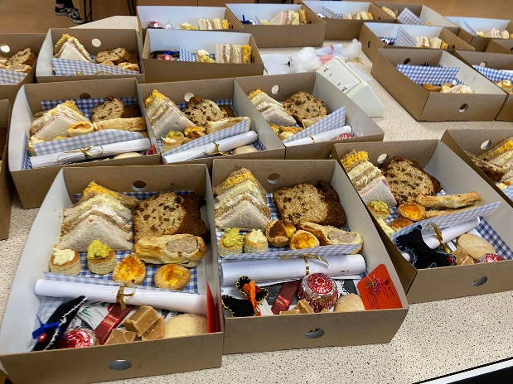We were delighted to get such positive feedback from our volunteers, supporters and clients following on from the success of our Afternoon Tea boxes for last year’s St. Andrew Day celebrations. The boxes were made by the intergenerational team at Fortrose Academy and were full of gifts, poems and delicious food which was all based around a Scottish theme. We were so thankful to our team of volunteers stepping in on their days off from Meals on Wheels deliveries too so that we could deliver them to you all. Black Isle Cares and the team at Fortrose Academy were so touched to receive the lovely comments which were sent back to us, and we thought it would be lovely to share some of the responses with you here:

*'What a beautifully presented and delicious afternoon tea I had delivered yesterday. I had it for my lunch, and it was greatly enjoyed. The variation and presentation of little gifts too was lovely. Many thanks.'*

*'Just a wee note to thank you all so much for the lovely boxes of 'goodies' that arrived yesterday. In these days when we are penned in by Covid rules it is great to know that we are not forgotten!! Indeed, thank you for all you do, BIC, Fortrose Academy and Age Scotland too. Here's to another life after Covid!'*

*'Dear all at Black Isle Cares and Fortrose Academy, thank you all so much for the lovely box of goodies you sent up to me on St. Andrews Day. It was so good of you to think of us all. Many thanks for all the people who delivered our meals every week as I appreciate it very much and it’s so nice to see them all as well. Thank you.'*

**Age Scotland handheld computers and Wi-Fi**

As you may be aware, Black Isle Cares recently received 6 *Lenovo* handheld computers, which now belong to BIC, and portable Wi-Fi for a 3-month period from Age Scotland. We have now given out 3 of these devices to people in the Black Isle who could benefit, and we are now looking to get the final 3 out to any of our Befriending or Meals on Wheels clients. The devices will arrive with you and already be set up for use. If you are interested but unsure about how to use one of these devices, then Black Isle Cares is happy to organize a ‘training session’ so you can learn to use the device confidentially. We hope that the devices could eventually be used remotely to connect individuals for catching up with loved ones and browsing the internet. Please let Megan know if you have any enquires or are interested in having one of these devices.

**Winter hardship**

Black Isle Cares understands the financial hardships which can become apparent during these winter months with the higher heating, fuel and energy bills, plus other relevant living expenses.

It is worth remembering that there is financial support out there and to discuss any need or benefit which you may be entitled too, please phone the Age Scotland helpline on 0800 12 44 222 or alternatively phone Home Energy Scotland on 0808 808 2282 to discuss options to reduce your bills. You can also visit the Home Energy Scotland website on <https://www.homeenergyscotland.org/warmer-winter/> for further information.

We are also keen to encourage those who are dealing with any issues affording Meals on Wheels to approach our Project Coordinator confidentially to discuss options which Black Isle Cares can assist with so individuals can continue receiving meals over periods of hardship.

**Feedback and ideas**

If you have any ideas or thoughts about any of our projects, please do get in touch by contacting us via email: [admin@blackislecares.com](mailto:admin@blackislecares.com) or by telephone: **07548343375.**