

**Black Isle Cares**

CHARITY NUMBER: SCO45371

Photo credit: Liam Skinner Photography

**April 2022**

Hello everyone and I hope you are well as we approach the brighter, slightly warmer weather. It is certainly encouraging to begin seeing the first signs of Spring and to know we are finally leaving the Winter of 2021 behind us! We are also starting to see the end of Covid-19 restrictions in our daily lives, and we hope as a charitable organisation that we will be able to start hosting events again in the near future to see all of you again. Things are beginning to look very hopeful, so we are in high spirits here at Black Isle Cares!

**Sunday Lunch Club**

Black Isle Cares has been informed of a new pilot, weekend project in the Black Isle which is to be run by Partnerships for Wellbeing over the coming weeks. One of the organisers, Hayley, has kindly written this short article to let us all know about the project, so if it is of any interest to you or anyone you may know then please do not hesitate to get in touch with her.

‘Partnerships for Wellbeing are piloting a new project, which if successful, will be run in addition to our existing Walking and Transport Projects.

Sundays are often associated with family, and we are looking for any older single person who might enjoy good company, a meal and friendly conversation one Sunday a month.

We are hoping to trial a lunch for 8 people on Sunday 3 April or Sunday 24th April to take place at the 19th Restaurant in Fortrose golf club. There is a varied menu, from a bowl of soup to a Sunday lunch. I have spoken with the restaurant, and they are very happy for people to pay their bill individually, so, you only pay for what you order! Drinks would also be paid for individually at the bar.

The hope is that this would be an enjoyable one Sunday a month meal out at a local restaurant with friends which suits everyone's size of appetite and 'pocket!'

It would be much appreciated if you could kindly let me know whether you would be interested in joining the Lunch Club on either of these Sundays in April.

My contact details are Hayley Tarbuck **01463 729997**. Please leave a message if I am not available and I will call you back as soon as I can!’

**Plastic Food Boxes**

It has come to light that there has been a bit of confusion lately in relation to the reuse of the plastic food boxes that are used for Meals on Wheels and what clients should do with them after they have had their meal. It would be great if the boxes/lids **aren’t** worn, cracked, or broken, if you are able to wash them out and put them out for our team of volunteers to collect on their next delivery round to you. The boxes will then either be passed back to the BIC office for sorting or put directly to one of our food providers to be disinfected and sterilized for use again. We are trying to be conscious of our environmental impact here at Black Isle Cares so it would be great if you can support us in this.

**Calman Trust and Black Isle Cares partnership working**

Black Isle Cares has recently been in discussions with the Calman Trust, a charity in the local area who support young people between the ages of 14-25 who are at risk of being left behind by their own personal challenges. The charity do a lot of work at developing these young people’s independence through a range of learnt life skills and one of their initatives involves young people preparing food for Café Artysans in Inverness. Through discussions with their CEO, Isobel Grigor, and BIC Chairwoman, Anne McDonald, it has been suggested that perhaps the young people at the Calman Trust could begin preparing and delivering food to a small number of our Meals on Wheels clients. We think this would be a wonderful partnership and we are in discussions to hopefully look at launching this idea in the coming weeks. So keep an eye out for more information coming soon!

**Black Isle United FC fundraising**

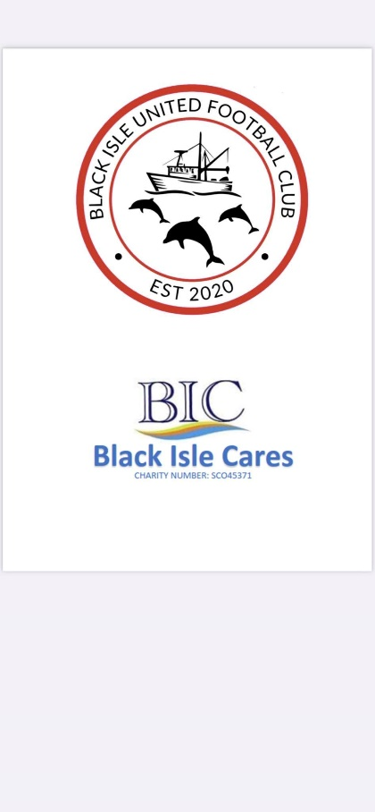Black Isle Cares was recently choosen by local football team, Black Isle United, to be their charity of choice for a annual fundraising event they host, with all profits being split between the team and the choosen charity. Through sales of raffle tickets for locally donated prizes, Black Isle United raised an incredible £626.37 for Black Isle Cares. A fantastic amount to enable us to continue with our many projects in the local area and give us a financial boost. Special thanks to Black Isle United manager, Sean Kelman for organising the fundraising and choosing us this year. If you want to keep upto date with this up and coming football teams progress in the upcoming season you can do so via their Facebook page: <https://www.facebook.com/Black-Isle-Utd-Fc>

**Black Isle Connections**

Black Isle Cares were delighted with our successful funding application to the Highland Council's Black Isle Ward Community Based Investment Fund.  We have been given £6000 to use towards a project called **Black Isle Connections – developing a resilient, age friendly community.**This will allow us to focus on the intergenerational connections that Black Isle Cares loves so much, and that have been very much missed over the last couple of years.

We will be looking to bring together the older and younger generations across the Black Isle, initially building on the existing BIC activities; Meals on Wheels, Befriending, Community Garden, and the Sharing Shed, but hoping to find new opportunities, such as partnerships with care homes and primary schools.

We will soon be recruiting for a very part time (7hrs a week) Intergenerational Development Worker, so let us know if you know of anyone who would be interested in the post.

**Feedback and ideas**

If you have any ideas or thoughts about any of our projects, please do get in touch by contacting us via email: [admin@blackislecares.com](mailto:admin@blackislecares.com) or by telephone: **07548343375.**